|  |
| --- |
|  |
| **System design document**  System Engineering**-**Gruppe E |
| **COP** |
| Prepared for: |
| Anders Jacob Truelsen (Systematic) |
| By: Anders Torndahl, Christian Jensen, David Neergaard Rasmussen Marmoy, Pedersen, Peter Høgh Mikkelsen |
|  |

|  |  |
| --- | --- |
| Table of Contents  1 Version history 2  2 Scope 2  2.1 Identification 2  2.2 System overview 2  2.3 Document overview 3  3 Referenced documents 3  4 System-wide design decisions 3  4.1 System behavior 3  4.2 The non-functional decisions for hwsw 4  5 System architectural design 5  5.1 System components 5  5.1.1 Identify components 5  5.1.2 Static depiction of component relationships 5  5.1.3 Purpose 5  5.2 Concept of execution 6  5.3 Interface design 6  6 Requirements traceability 6 | |
| System design document | |
| Project: | $System Engineering**-**Gruppe E |
| Revision: | $Revision: 1.0 $ $Date: 071010 $ |
| Document: | $ |
|  | |

# System identification

|  |  |  |
| --- | --- | --- |
| Version # | System name | Date |
| 1.0 | COP | 071010 |
|  |  |  |

# Scope

## System overview

The purpose of the system being developed is to give a common operations picture over a disaster area. This system relies on an already existing system called SitaWare which is designed for military use. The purpose of this system is to extend the possibilities from the existing system, in a civilian capacity. The system, consist of the mobile HQ and mobile handheld devises. Through these devises the users can access important information, which is prioritized and shared by the commander. The users are defined in the requirements specification.

The commander has access to information via the internet, and other sources, and the commander has the overview of the situation by having contact with all of the parties involved. The way the commander communicates and shares information is through the systems handheld devices.

In Figure 1 an overview of the information and communication structure can be seen.

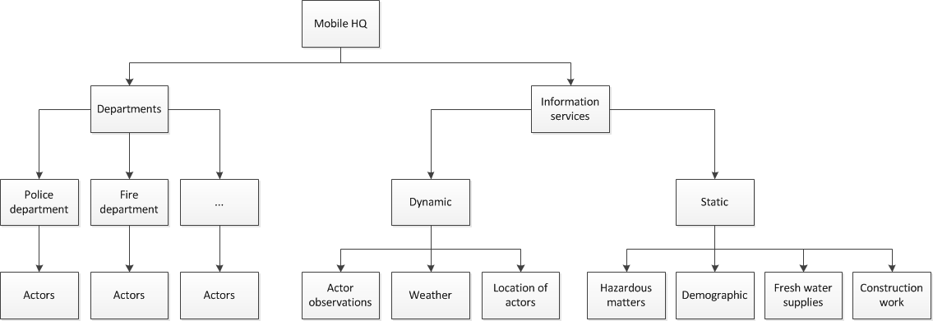

Figure Communication structure overview

## Documentoverview

***Section 2: Referenced documents*** - Lists the titles and version numbers of documents referenced in this document.

***Section 3: System-wide design decisions*** – Presents decisions about the system’s behavioral design (how it will behave, from a user’s point of view, in meeting its requirements, ignoring internal implementation) and other decisions affecting the selection and design of system components.

***Section 4: System architectural design*** – Consists of subsections:

*System components* Identifies the components of the system, shows the static relationship(s) of the components. States the purpose of each component and identifies their development status/type.

*Concept of execution* Describes the concept of execution among the system components. It includes diagrams and descriptions showing the dynamic relationship of the components, that is, how they will interact during system operation.

*Interface design* Identifies and describes both interfaces among the components and their interfaces with external entities such as other systems, configuration items, and users.

***Section 5***: ***Requirements traceability*** – References traceability matrix, specifying the relationship between the system requirements and system components.

# Referenceddocuments

Requirements Traceability Matrix v.2

subsupplier system design document SSDD_COP_Dismounted_DocID_COPDvA.

# System-wide design decisions

## System behaviour

**System behaviour for the mobile headquarters**

For the mobile HQ, the requirements dictate that the commander has to be able to receive information supplied by the people using the handheld devises, and other sources, as stated in Requirements Traceability Matrix v.2 SCOP- 0007. From this information, the commander has to be able to send out the appropriate teams to the appropriate tasks. This part of the user interface is yet undefined, and needs a use case description to describe the behaviour in more detail.

**System behaviour for the handheld devices**

Since no software has yet been developed for this system, the description of its behaviour is limited. For the user interface there are several levels of access for different groups of users. These requirements dictate the behaviour of the user interface with the hand held devises as stated in Systematic case under the section Requirements.

The user logs on to the system with a user name and a password, thereby defining which user group they are a part off. The idea is that the information that does not concern the particular group of user won’t be accessible. Either the option to access this information won’t be visible, or it will be visible, but will return a message when accessed saying that this is restricted information for the current user. It is difficult to make this decision without knowing what is most comfortable for the users.

When a user inputs a command that is not acceptable, the device must send a clear graphical message about the error the user is making, and quickly return to its original state of operation. This message should not be shown for longer than necessary. This is not a requirement, since this issue has not come up yet doe to the scope of this project.

The general access times for the different actions the user makes, must have minimum time duration, it is important that the device is as stress less and smooth operating as possible. Again, this is not a requirement, doe to the scope of this project. There are no requirements on these times, but there should be defined some ideas about comfort and user friendliness. Further user interaction on the handheld device is not yet designed, and is mostly up to the subcontractor. The subcontractor has a list of requirements that must be met. Se requirements specification RS for sub-supplier. The user interface is widely up to the subcontractor.

## The non-functional decisions for hwsw

**The nonfunctional decisions for mobile headquarters.**

The mobile HQ is versioned as a panel of screens, where a very intuitive and easy to use layout is desired. Since the command center has not been laye´d out yet, there has been no decisions on how the layout shall bee. A general solution could be used here. For example the commander could have multiple screens, each showing different information, the center screen and to screens, one on each side of the centre screen. The screens are not touch screens, so the commander will have to use a standard keyboard. The reason for this decision is that the commander has more comfort working on a keyboard at his workstation, and makes for more effective operation. This is an assumption though, and more research in this area must be made to find the most effective solution.

**The nonfunctional decisions for the handheld devices.**

The decision to use a touch screen was based on the desire to make the device as intuitive and easy to use as possible. In a critical situation, the user must not be weighed down by difficulty using the devise. The interface software on the devise is intended to be functional even when the user is wearing gloves. This means that the soft keys must by large enough for use with a glove. An intelligent touchpad algorithm to solve this problem could also be implemented; this is the subcontractor’s decision, since they Have the expertise in this area.

The size of the screen shall be between 10” and 12” as stated in requirements specification RS for sub-supplier TPOD-0008. This should fit with the standard readymade touch screens on the market, and is therefore easy and cheap to implement. The material of the device is up to the subcontractor to decide, though it must comply with the requirements that are given in the requirements specification RS for sub-supplier TPOD-0009

The battery can be a standard lithium polymer battery, which is a very lightweight and reliable battery type. The idea to use this type of battery was made because this is becoming the most commonly used battery type in handheld devices, and a variety of ready made solutions exist both for charging and maintaining the battery. Still this is not a requirement for the sub supplier.

# System architectural design

## System components

### Identify components

SitaWare HQ id: component0001

Dismounted id: component0002

Central data access id: component0003

Meteorology database id: component0004

GIS database id: component0005

Demography database id: component0006

GPS system id: component0007

Existing digital radio platform id: component0008

Existing phone platform id: component0009

### Static depiction of component relationships

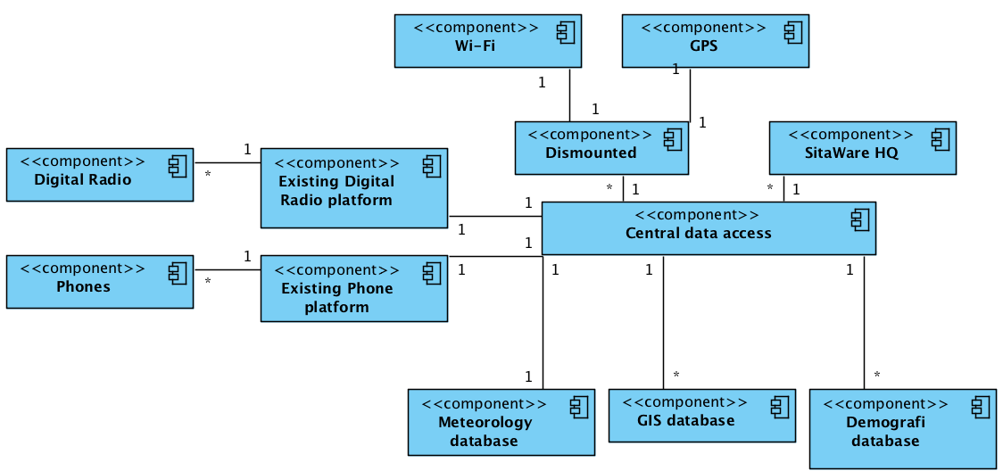

Figure Static depiction of component relationships

### Purpose

#### Component0001 SitaWare HQ

Requirements SCOP-0014, SCOP-0016, SCOP-18 and SCOP-19 are allocated to SitaWare HQ.

SitaWare is an existing component to be used as is.

The current version available is SitaWare HQ 5.xx

#### Component0003 Central data access

The central data access has two purposes.

1. To act as a system local data backup for the public data that the system relies upon.

2. To serve as a central data access point for the rest of the system component. All the functional system requirements SCOP-0001 – SCOP-0012 are allocated to the central data access. The central data access point provides interfaces for distribution-controlled data extraction and implements interfaces to distribution-controlled data infusion from external sources. It is the responsibility of the central data access component to supply the data in the format expected by the relevant components, such as SitaWare HQ, and the dismounted solution.

#### Component0002 Dismounted solution

The dismounted solution architecture is described in Subsupplier system design document SSDD_COP_Dismounted_DocID_COPDvA.

#### Component0008 Existing digital radio platform

The existing platform in use by the police and fire department, called ”system name” in version ”version number” will be incorporated as is.

## Concept of execution

This paragraph has been tailored out

## Interface design

Interface Control Document

# Requirementst raceability

Requirements Traceability Matrix v.2